Website material for TESLA Chair

You may copy and paste the material below onto your website. For layout guidance please see this link - https://www.cryomed.com.au/product/teslachair/

Please contact us at advertising@cryomed.com.au for any questions or for further help. We appreciate your continued support.

TESLAChair Functional Magnetic Stimulation
The TESLA Chair is a breakthrough treatment for incontinence and confidence. This unique technology revolutionises sexual health and wellness by providing those suffering from incontinence with a completely non-invasive and effective option for management of symptoms.

TESLAChair for Urinary Incontinence
The TESLAChair was developed for treating weakened pelvic floor muscles and urinary incontinence using the special Functional Magnetic Stimulation (FMS) technology. The pulsed magnetic field generated by the device causes the muscles of the pelvic floor to contract. This therapy is suitable for all kinds of urinary and faecal incontinence. FMS also helps patients with sexual dysfunction and chronic pain in the pelvic region and lumbar spine. The magnetic stimulation results in increased strength and endurance of pelvic region and pelvic floor muscles.

TESLAChair for Lower Back
The new TESLAChair treatment is a painless, non-invasive and effective therapy for problems in the lower back area. The treatment stimulates muscles, and accelerates circulation without direct contact with the skin. The therapy procedure is simple, and the patient does not require special preparation. During the therapy the patient simply sits in the chair. Stimulation of the lower back can be accurately targeted by changing the position of the applicator in the chair backrest.
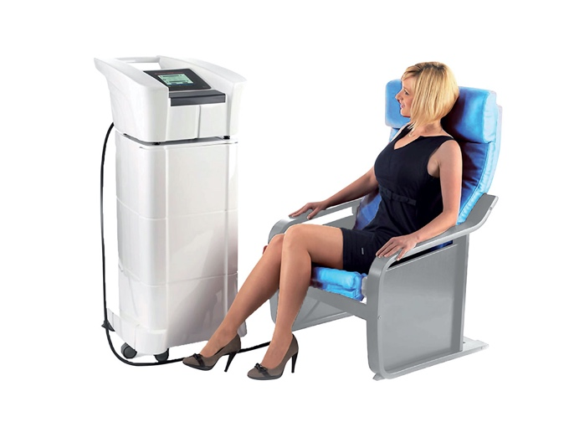

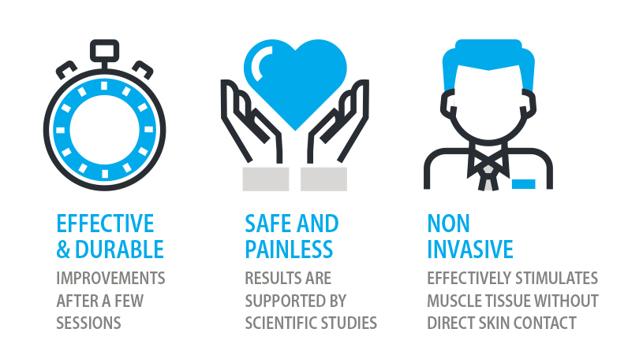

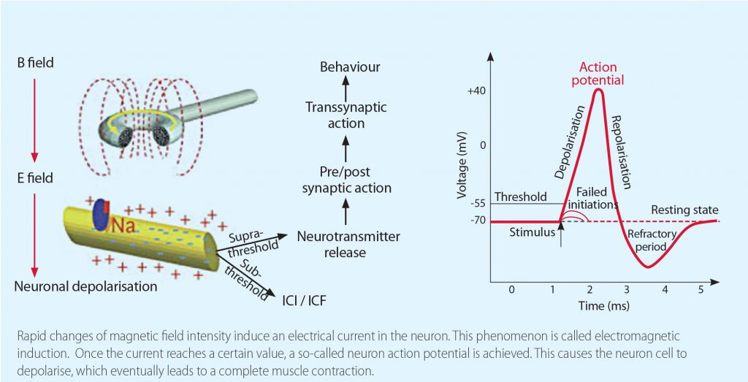

FREQUENTLY ASKED QUESTIONS
WHAT IS FMS?
FMS stands for Functional Magnetic Stimulation which delivers up to 3 tesla. A special magnetic ﬁeld is generated by a pulse of current inside the EM (electro magnetic) mechanism, and this induces a current that triggers the motor nerve system of the body, stimulating the targeted muscles to contract, and helping to boost circulation and nutrition.
WHAT DOES TREATMENT FEEL LIKE?
Patients are seated and fully clothed when being treated in the comfortable TESLA Chair. The therapy is non-invasive, painless and without any known side effects.
You will be encouraged to concentrate on muscle contraction during the stimulation. This facilitates the implementation of active learning exercises.
IS IT SUITABLE FOR MY PROBLEM?
The treatment is suitable for all types of urinary and faecal incontinence. It is used for faster rehabilitation after surgeries in the urogenital area, after childbirth and for some sexual dysfunction and chronic pelvic and lower back pain. You will complete a questionnaire and receive a physical examination as part of your assessment for treatment.

TESLAChair INCONTINENCE & PELVIC FLOOR INDICATIONS
• Urge urinary incontinence
• Stress urinary incontinence
• Mixed urinary incontinence
• Incontinence after radical prostatectomy
• Faecal incontinence
• Regeneration after childbirth
• Milder forms of drooping uterus and bladder (cistokela, descensus uterusa)
• Rehabilitation after pelvic ﬂoor surgery
• Chronic prostate inﬂammation
• Erectile dysfunction
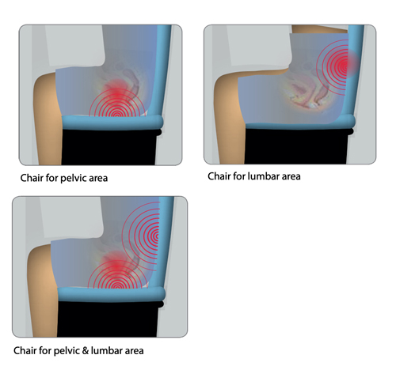

PILOT STUDY RESULTS
The graph below shows the results of therapy using the TESLAChair after 16 treatment sessions. The results were collected in three independent centres with 160 female patients. Thirty-six women were treated for urge urinary incontinence (UUI), 42 women were treated for mixed urinary incontinence (MUI), 61 women were treated for stress urinary incontinence (SUI) and 21 women were treated for urinary incontinence after childbirth

ADVANTAGES:
• Deep stimulation of muscular structures
• More active than electrostimulation
• Painless and non-invasive therapy
• Suitable for patients where electrotherapy cannot be used
• No skin contact
• Hands-free operation
