The World’s First Portable Face Lifting & Body Contouring System

Two ground-breaking technologies in one device: Micro Focused Ultrasound and Macro Focused Circular Ultrasound.
- Comfortable treatment for patients, with no prior preparation or anaesthesia required
- Patients will see immediate results in skin tightening and some size reduction, as well as ongoing improvement
- Ulfit provides highly focused treatment for areas of concern.
- Optional “P” mode dramatically increases treatment comfort levels
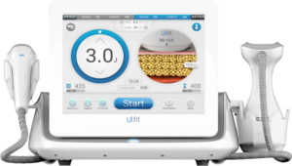
- Low downtime

Advanced face and body lifting and contouring

Ulfit lifts and tightens most areas of the face:
- Forehead and Periorbital
- Eyebrows
- Wrinkles
- Cheek, jowl line and v-line
- Chin and double chin
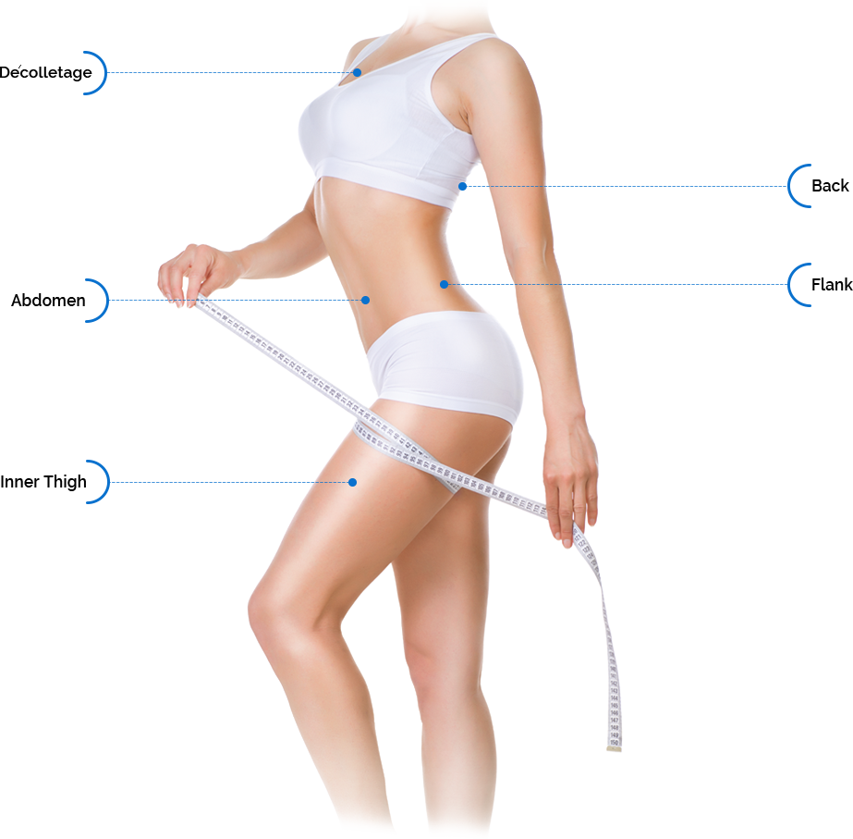
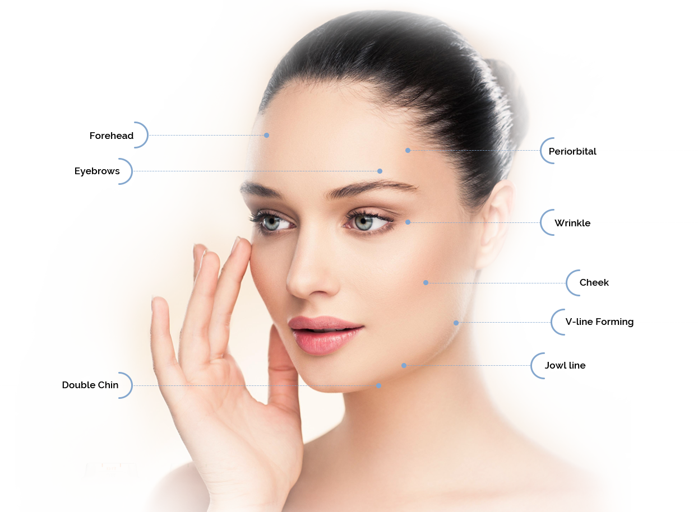

Ulfit’s body cartridge has a unique circular motion design that enables the ultrasound energy to cover larger areas more efficiently:
- Décolletage
- Back and flanks
- Abdomen
- Inner and outer thighs

Clinical Results
Patients will experience an immediate result in skin tightening and size reduction; however, the full benefit of Ulfit treatment, occurs after several weeks, when the tissues have fully responded to the coagulation caused by the ultrasound energy
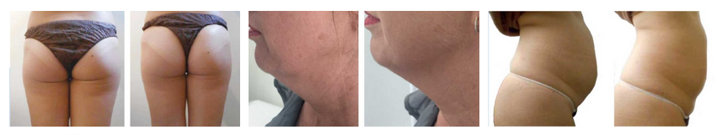

The smart choice for a busy clinic
- Ulfit’s portability means you can easily provide treatments in different areas of your clinics, depending on space and room availability.
- This hard-working device offers effective treatments for both face tightening and body contouring
- It provides immediate results as well as ongoing improvement
- Exchangeable cartridges for efficient treatments
- Incorporates powerful and effective innovations, such as Perpetual Operation, Motional Body Applicator and optional “P” control
- Excellent ROI.
- Several different cartridge depths for face and body ensure highly targeted and effective treatment of all areas
- Ultrasound energy is projected deep into the subcutaneous fat layers for maximum effectiveness of body treatments
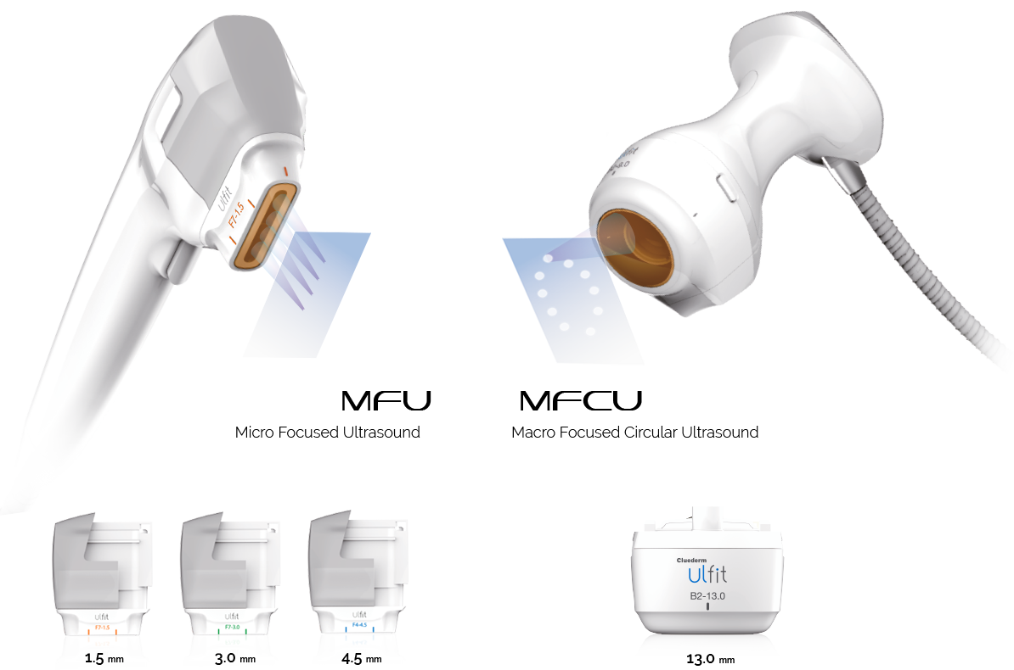

Ulfit In Depth
Macro Focused Circular Ultrasound (MFCU) for Body Contouring
- Industry-first circular design of body cartridge equipped with MFCU technology
- Provides equal and precise distribution of ultrasound energy
- Custom-designed 2MHz transducer conducts perpetual rotation within the handpiece
- This results in extensive projection of ultrasound energy deep into the subcutaneous fat layers

Micro Focused Ultrasound (MFU) Technology for Face Lifting
- Three exchangeable cartridges for face lifting target different depths: 1.5mm, 3.0mm and 4.5mm
- This maximises treatment benefits and allows the practitioner to treat virtually every part of the face

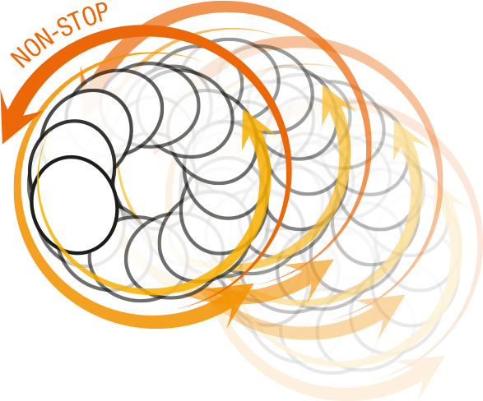
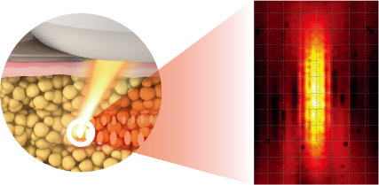

2MHz, 13.0mm focused ultrasound beam delivers high density power to the focal region.
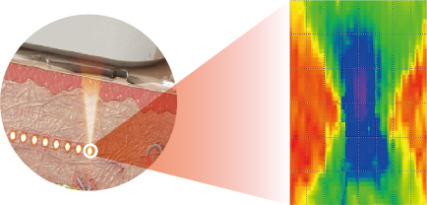
4MHz, 4.5mm focused ultrasound beam delivers controlled energy with precision to the focal region.

Hyperthermia Lifting Therapy
Ulfit applies 65-75°C of High Intensity Focused Ultrasound (HIFU) to the specifically targeted layer of skin tissue, creating skin coagulation at that layer, but without any damage to the surrounding area or the skin surface.
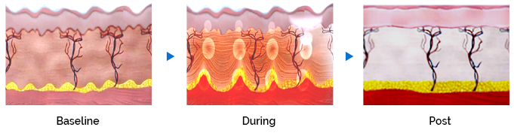

Wound Healing Process
Ulfit HIFU treatment results in haemostasis (inflammation) of the treated area. During the proliferative phase, tissue granulates,the wounded cells contract, and collagen synthesis begins. This leads into a skin remodelling phase where the collagen
fibres strengthen and rearrange themselves, the skin tightens and lifts, and the fat layer is reduced.
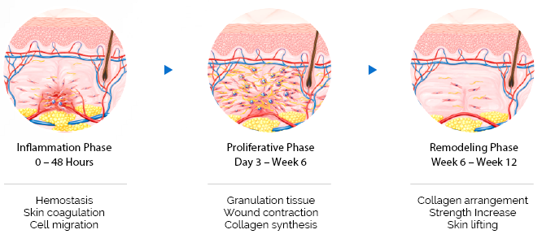

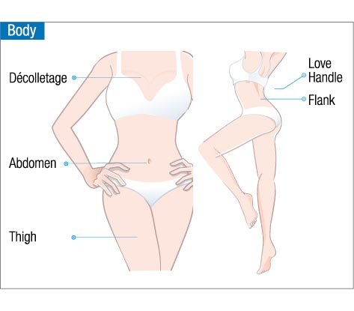
Specifications

Energy Type | Focused Ultrasound (MFU & MMFU)
Energy | 0.1J – 0.9J
Power | 100-240V, 50-60Hz
Weight | 8.2kg
Dimensions | 360 x 460 x 150mm
Cartridges | F7 1.5mm 7MHz  F7 3.0mm 7MHz  F4 4.5mm 4MHz  B2 13.0mm 2MHz

