The Gold Standard Solution to Reduce Stubborn Fat
CLATUU ALPHA is the world No.1 Dualsculpting system with precise 360° surround cooling that achieves maximum coverage of the treatment area and provides fast and eﬀective dual handpiece fat-freezing treatments. The CLATUU system maintains a constant target temperature that prevents unwanted side eﬀects with a proven track record of dependability and clinical eﬃcacy.

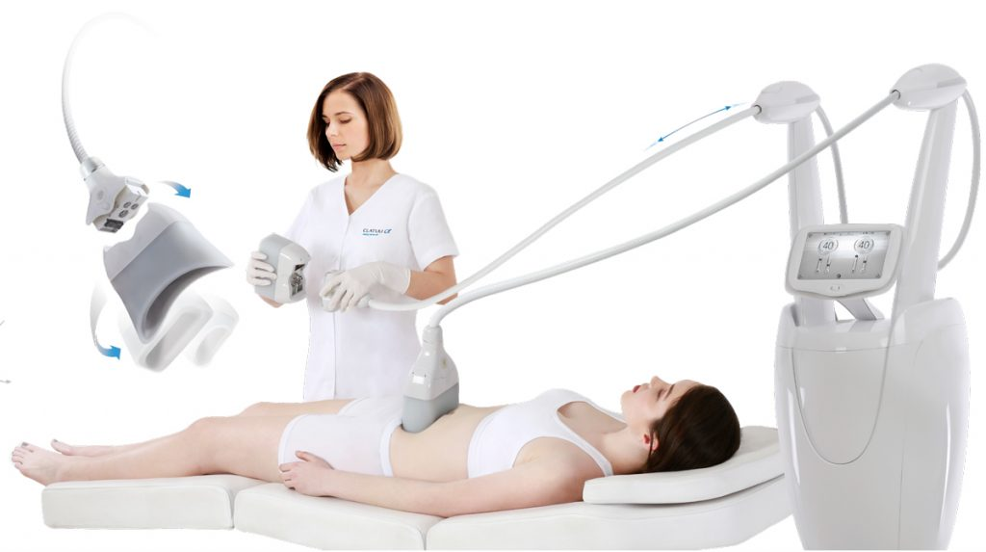

Fast and Easy Applicator Exchange
With a simple press-and-release mechanism, the CLATUU Alpha allows maximum convenience and makes switching cooling cups as simple as possible. Detaching cables or turning the system off is not required even during treatments.
Various Applicators for any Spot
The CLATUU ALPHA’S wide range of cooling cups are designed to perfection within our R&D labs and are suitable to conform to a large variety of body shapes and patients. Each individual cup helps to achieve a variety of customized treatment plans to effectively reduce fat cells for the ultimate dual sculpting body contouring experience.

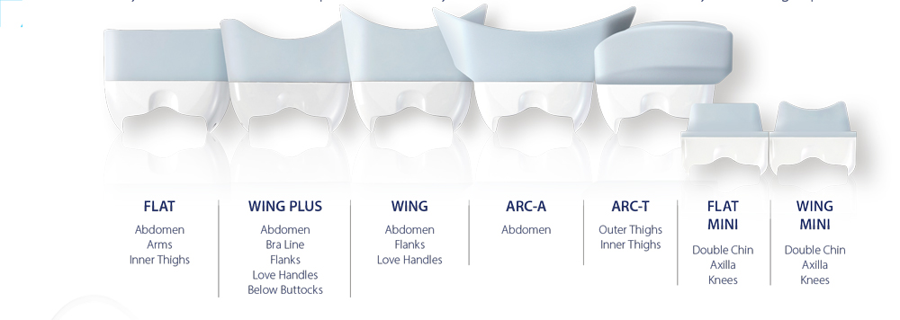

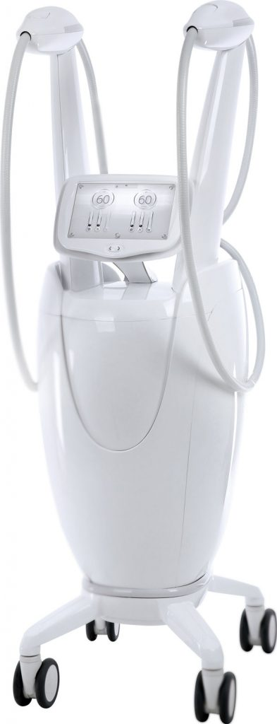

Applicators Optimized for Any Treatment
After laborious testing and research, each individual cooling cup has been ergonomically designed to adhere to each curve of the body.
The CLATUU ALPHA has been optimized to achieve desired outcomes from head to toe.

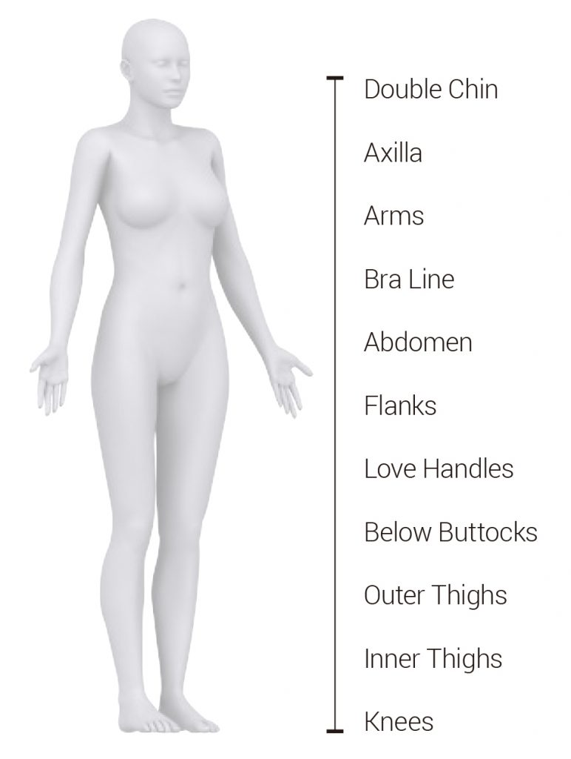

Advanced Technology for Maximum Results
Having accumulated countless hours in research and development, the CLATUU ALPHA features a revolutionary approach to absolute, non-invasive body contouring through a more powerful cooling technology.
Upgraded 360° Surround Cooling
360° Surround Cooling Technology unlike the conventional two-sided cooling methods, increases efficiency by up to 18.1%. Allowing delivery of cooling to the entire cup and in result removes fat cells more effectively.
Dualsculpt with Applicators
The CLATUU ALPHA has the ability to have two high-speed handpiece applicators treating at the same time allowing dualsculpting to take place.Faster to Target Point
The cooling system of the CLATUU ALPHA is engineered to reach its target temperature faster than previous models, reducing the inconveniences of waiting and maximizing time efficiency for both patients and physicians.

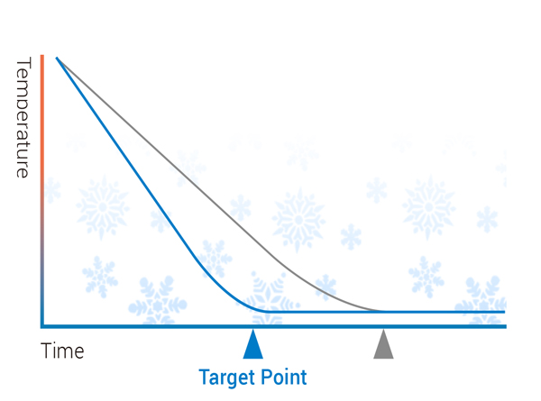

Adjustable Levels
Not only is the CLATUU Alpha capable of 20% stronger suction, it also provides medical practitioners with the ability to adjust both cooling and suction levels to confidently provide customized treatments for patients.
Science Behind ALPHA
Each cooling applicator is engineered to target the patient’s subcutaneous fat layer without damaging surrounding tissues or nerve regions, It is through this advanced cooling technology that we are able to welcome you to the Innovative Age of ALPHA.

