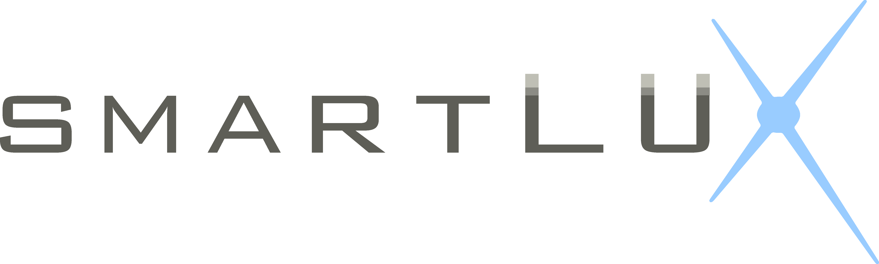

Client Consent Form

LED is a new approach to maximise facial rejuvenation by ways that are non-invasive, respecting the physiology and biology of the skin and muscles. Unlike IPL and other lasers that rely on thermal injury to prompt the skin to repair it’s self, Light emitting diodes (LED) do not produce any heat. They stimulate naturally occurring regeneration and repair processes of the skin.

The LED will improve hyperpigmentation, redness problems and reduce the signs caused by the skin’s natural ageing process. Photobiostimulation is an excellent way to increase collagen production in the skin, keeping it younger and healthier looking longer.

These results will occur gradually during the treatment series, an average of 10 to 12 treatments are required. The number may very depending the response.

The light used during LED treatments is similar to natural day light and can’t cause any allergic reaction. Some skins may experience momentary redness following a treatment.

Individuals prone to dizziness may experience discomfort. These reactions are temporary and with no consequence.

The result of any treatment depends upon the individual skin metabolism of each person. It is important to understand that the speed at which results are achieved as well as the outcome can never be exactly predicted. The number of treatments sessions that will be needed will be estimated approximately and may change during the course of the treatments series.

It is important that you attend your scheduled appointments in order to obtain the best possible results.

We advise that after any rejuvenation treatment sunscreen is applied and regular sunscreen is applied for outdoor activities.

There is no Guarantee that the achieved results will match the results that are desired. Some skin conditions are due to underlying problems, which, if not resolved, may cause the condition to reappear once the treatment series is completed. Furthermore, skin ageing is a natural process that cannot be stopped, although it maybe slowed down. It is therefore recommended to follow a maintenance program recommended by your therapist in order to maintain results.

I have read all the above explanation and recommendation regarding LED treatments. I understand the advantages and the limitations of the treatment. I agree to follow the recommendations given to me by my therapist or aesthetician in order to achieve the best results. I understand that there are no guaranteed results and that maintenance is necessary.

Client Name: __________________________________________________________________________________________________

Telephone No: ________________________________________________________________________________________________

Signature: _____________________________________________________________________________________________________

Date: ____________________________________________________________________________________________________________

TERMS OF USE: This form should be reviewed periodically to ensure that its contents are current. Cryomed Australia cannot and does not recommend standard operating procedures related to the practice of medicine. Cryomed does not accept liability for its contents. It is essential that each clinic customize the consent form according to treatment procedure, state law requirements, and language. Cryomed does not make any representation, guarantee or warranty, express or implied or assume any liability or responsibility for the accuracy or completeness of the contents of this sample form. You should seek your own legal advice independently or through your insurance policy provider along with insurance advice. Practitioners and staff are responsible to ensure that patients receive accurate information concerning the nature, risks and costs associated with a given procedure or treatment.

