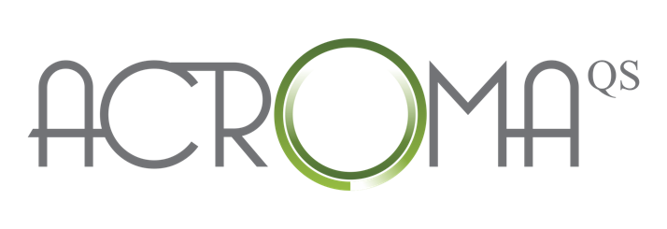

ACROMA PATIENT CONSENT FORM

Doctor/Practice Name Address
Phone

CLIENT INFORMATION
NAME: DATE:

GENDER: ❑ F ❑ M D.O.B.

FITZPATRICK SKIN TYPE SKIN CONDITION/S TO BE TREATED.

PRE-TREATMENT PHOTOS TAKEN:  YES NO

Procedural consent Q-SWITCHED LASER
- Before you undergo Q-switched laser treatment make sure you have read and fully understood the background information on the procedure. To get the most out of it, you need to understand the nature of the procedure, the associated benefits and risks, as well as the available treatment options.
- Photos are routinely taken before treatment as a visual record. These may be used for teaching purposes and may be shown for scientific purposes including publications in medical journals. There will be no identification of the images, and they will remain the property of this clinic.
- For best results, it is necessary to have the full series of pre-determined treatment sessions. In a minority of patients, the Q-switched laser procedure may not work satisfactorily or may not last for the expected period of time. As it’s not possible to predict a sub-optimal response, we are unable to guarantee expected outcomes, nor the number of treatment sessions needed for satisfactory outcomes.
- By signing the informed consent, you acknowledge that all the above issues relating to the procedure have been addressed; and that you’ve been given ample opportunity to ask questions and raise any concerns relating to the procedure.

Please mark any conditions or medications that apply to you in the boxes below:

❑ Gold Therapy ❑ Easily bruised ❑ Skin laceration ❑ Heart disease
❑ Pregnancy ❑ Recently tanned ❑ Active cold sores ❑ Bleeding disorders
❑ Lupus ❑ Scleroderma ❑ Vasculitis ❑ Induced photosensitivity
❑ Diabetes ❑ Histamine Prone ❑ Polycystic Ovarian Syndrome ❑ Cosmetic Tattoo

If you have ticked any of the above boxes, you will be referred to a medical doctor for consultation prior to undergoing Etherea treatment.
CONTRAINDICATED MEDICATIONS:
- ❑ Anti-coagulants. ❑ Cortisone ❑ Insulin. ❑ Roacutane or Retin-A
- ❑ Steroids ❑ Tranquillisers ❑ Antipsychotics. ❑ Thyroid medication

- ❑ Other (please indicate): _____________________________________________

patient’s declaration
- The nature of Q-Switched Laser treatment has been explained to me. I understand that just as there may be benefits from the procedure, all procedures involve risk to some degree. I am aware that other unexpected risks or complications may occur and that no guarantees or promises have been made to me concerning the results of the procedure. It has also been explained that during the course of the proposed procedure, unforeseen conditions may be revealed requiring performance of additional procedures. My questions regarding this treatment, its alternatives, its complications and risks have been answered by my practitioner and/or his or her staff.
- My signature on this consent form indicates that I have read and that I understand the information provided. I consent to the treatment described, and I agree to comply with the requirements placed on me by this consent form.

CONSENT FOR TREATMENT

I have read and understand the information contained within this consent form. My signature on this consent form indicates that I have read and understand the information in the consent, my consent to the treatment described, and my agreement to comply with the requirements placed on me by this consent form.

I have informed the patient of the available alternatives to treatment and of the potential risks and complications that may occur as a result of this treatment.

I have read this form and understand it, and I request the performance of the procedure.

____________________________________________________________________________________
Patient Signature

____________________________________________________________________________________
Practitioner Signature

