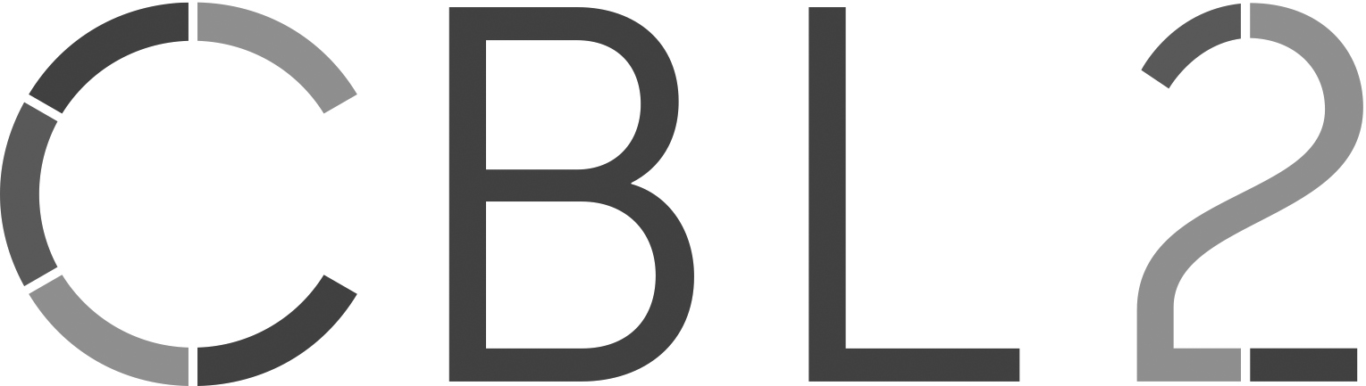 SAMPLE CONSENT FORM

I understand that the CBL2 is a device used for hair removal, skin rejuvenation, acne treatment, wrinkle reduction, skin resurfacing, facial redness and vascular lesion treatments.

I am consenting to be a patient receiving _______________________________ treatment (specify procedure).

I understand that clinical results may vary depending on individual factors, including but not limited to medical history, skin type, patient compliance with pre- and post-treatment instructions, and individual response to treatment.

I understand that there is a possibility of short-term effects such as reddening, mild burning, temporary bruising and temporary discoloration of the skin, among others, as well as the possibility of rare side effects such as scarring and permanent discoloration. These effects have been fully explained to me.

I understand that treatment with the CBL2 involves a series of treatments and the fee structure has been fully explained to me.

I certify that I have been fully informed of the nature and purpose of the procedure, expected outcomes and possible complications, and I understand that no guarantee can be given as to the final result obtained. I am fully aware that my condition is of cosmetic concern and that the decision to proceed is based solely on my expressed desire to do so.

I confirm that I have informed the staff regarding any current or past medical condition, disease or medication taken.

I consent to the taking of photographs and authorize their anonymous use for the purposes of medical audit, education and promotion.

I certify that I have been given the opportunity to ask questions and that I have read and fully understand the contents of this consent form.

Patient Name DOB

Patient Signature Date

Witness

