❖
❖

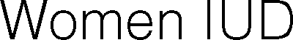
❖
 
 
❖
 
 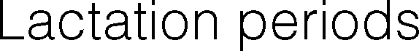
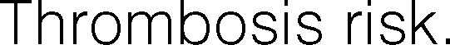
❖
 
 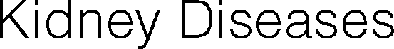
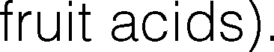
❖
❖

  - Internal bleeding proceses in acute phase.
  - Patients undergoing declotting treatment.
  - In the first 48 hours of postoperative for certain pathologies.
  - Metallic prostheses carriers.
  - Patients with malignant neoplasm.
  - People who are non-sensitive to temperature. Infectious processes in action.
  - People who suffer uncompensated arthropathies.

I UNDERSTAND that the finality of this treatment is to improve my personal appearance having the possibility that some imperfection will persist and the result will be not the wished by me. I'm aware that medicine it's not an exact science and nobody can guarantee to me the absolute perfection. I aware that the result could not be the expected by me and I recognize that nobody gave me such guarantee.

I HAVE BEEN INFORMED that number of necessary treatments to get the wished effect has been informed to me in an indicative way, being impossible to know in advance, the numbers of sessions which are necessary due to the different reaction of each patient.

I COMMIT myself to follow faithfully, at the best of my possibilities, the operator instructions before, during and after the treatment mentioned before. Being under my responsibility the compliance of the recommended prescriptions done by the Center.

I CERTIFY not to modify or omit my personal information or my medical history and clinic-surgical antecedents, specially referred to allergies, illness or personal risks.

I GIVE MY CONSENT, to take photographs on the treated zone of my body to be used for scientific, teaching or medical purposes. It being understood that its use does not constitute any violation of privacy or confidentiality, to which I am entitled.
I have been informed, also, my right to refuse treatment or revoke this consent.

I was able to answer all my questions about all the above and I fully understand this consent in every one of its points and signed the document IN ALL PAGES AND DUPLICATE ratify and consent to treatment is obtained.

Patient name: ____________________________________ Signature: ______________________________

Date: ___________________________________________ Witness: ________________________________

TERMS OF USE: This form should be reviewed periodically to ensure that its contents are current. Cryomed Australia cannot and does not recommend standard operating procedures related to the practice of medicine. Cryomed does not accept liability for its contents. It is essential that each clinic customize the consent form according to treatment procedure, state law requirements, and language. Cryomed does not make any representation, guarantee or warranty, express or implied or assume any liability or responsibility for the accuracy or completeness of the contents of this sample form. You should seek your own legal advice independently or through your insurance policy provider along with insurance advice. Practitioners and staff are responsible to ensure that patients receive accurate information concerning the nature, risks and costs associated with a given procedure or treatment.

