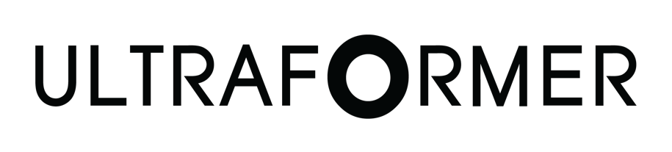

PATIENT CONSENT FORM
CLIENT INFORMATION DATE:
NAME: D.O.B.

Pre-Treatment Photos Taken: ❑ Yes ❑ No

ABOUT ULTRAFORMER
Ultraformer treatment promotes non-surgical face lifting and skin tightening to a number of problem areas, including the difficult-to-treat sub-mental zone, i.e., the area under the chin. It can also be used for skin tightening on small problem areas of the body and limbs.
During Ultraformer treatment, low amounts of Micro-Focused Ultrasound energy are delivered into precise skin depths, without damaging the surface of the skin. The MFU energy creates heat, which stimulates tissue remodelling. The result, over time, is a natural skin lifting, tightening and rejuvenation.

WHAT TO EXPECT DURING AND AFTER YOUR ULTRAFORMER TREATMENT
- You can expect to experience some discomfort as the ultrasound energy is delivered. Your practitioner will agree a plan to optimise your comfort during the procedure.
- Ultraformer treatment is efficient. For example, a treatment for the full face and neck will last approximately 30-45 minutes.

POSSIBLE SIDE EFFECTS FROM ULTRAFORMER TREATMENT

- Your skin may appear red for a few hours after Ultraformer treatment.
- You may experience slight swelling, tingling or tenderness for a few days after treatment. Rarely, some patients may experience temporary bruising welts or numbness.
- As with any heat-based treatment, there is a slight risk of burning the skin.
- Temporary nerve inflammation will resolve in a few days or weeks.
- If a motor nerve has become inflamed, you might experience some temporary local muscle weakness. There could be some temporary numbness if a sensory nerve has become inflamed.

CONSENT FOR ULTRAFORMER TREATMENT

PATIENT’S DECLARATION
I have read and understood all the information provided and I have had the opportunity to ask any questions concerning the nature of the treatment, its expected results, and its possible risks and complications.
It has been explained to me that the results of Ultraformer treatment can vary from patient to patient. I am aware that occasionally the collagen that builds in the deep layers of the skin, providing support for the skin structure and helping to counter the effects of gravity, might not have a visible effect on the surface of the skin. I also understand that the results will be seen gradually over a period of 3 to 6 months, and that some patients will benefit from more than one treatment.
I understand that Ultraformer treatment is a non-invasive treatment. It is not designed to produce the same results as an invasive surgical procedure.

PATIENT’S NAME:
PATIENT’S SIGNATURE: DATE:
THERAPIST’S NAME: DATE:
THERAPIST’S SIGNATURE: DATE:

TERMS OF USE: This form should be reviewed periodically to ensure that its contents are current. Cryomed Australia cannot and does not recommend standard operating procedures related to the practice of medicine. Cryomed does not accept liability for its contents. It is essential that each clinic customize the consent form according to treatment procedure, state law requirements, and language. Cryomed does not make any representation, guarantee or warranty, express or implied or assume any liability or responsibility for the accuracy or completeness of the contents of this sample form. You should seek your own legal advice independently or through your insurance policy provider along with insurance advice. Practitioners and staff are responsible to ensure that patients receive accurate information concerning the nature, risks and costs associated with a given procedure or treatment.

